Setup and Demo Guide
- Benny Giorno
- Shachar Shoshani
- Github link - https://github.com/ShacharShoshani/Afeka_Academic_Final_Project.git

Launch the app
- Reset the database:
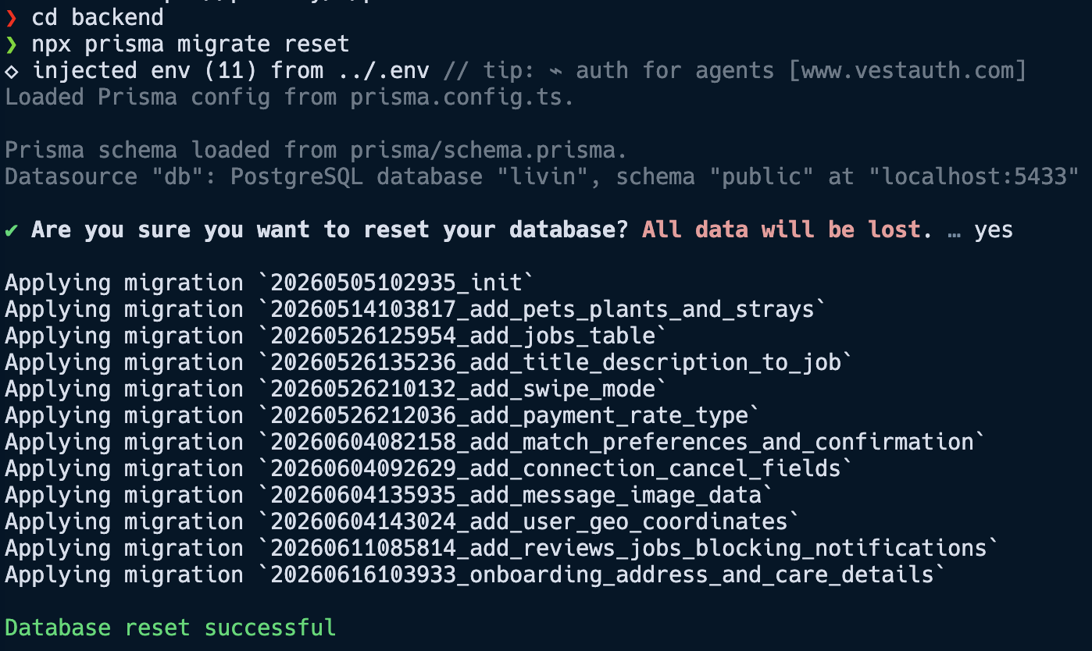
- Verify docker containers are running:
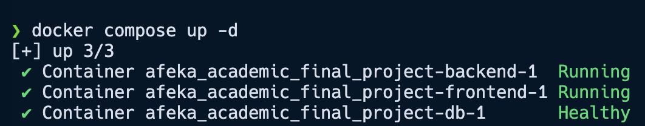

User Signup
- Launch the app from two different browsers and create new users as detailed in DEMO.md: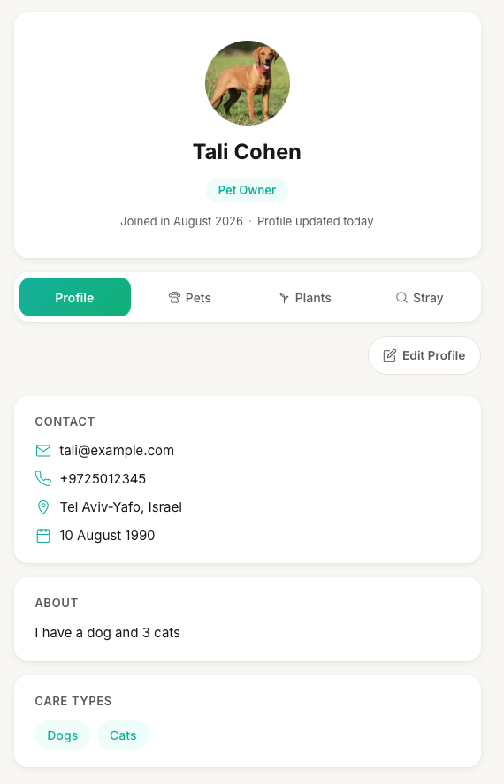
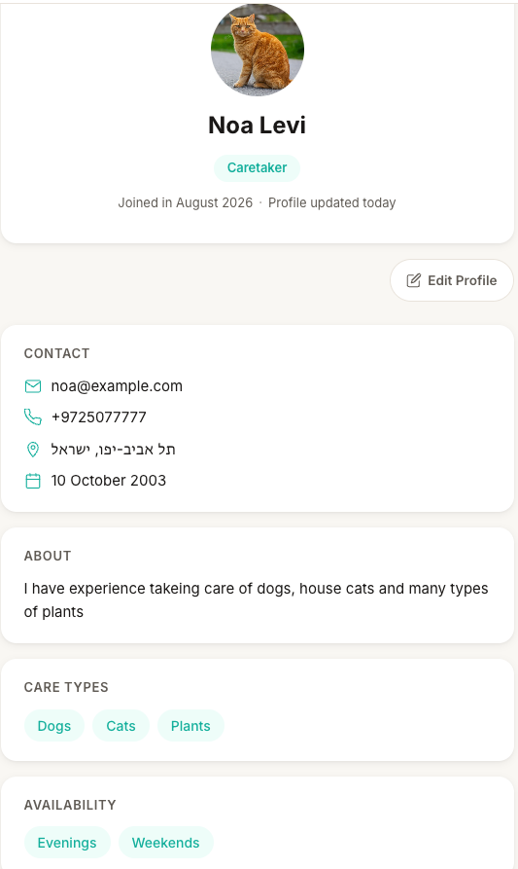

Job Posting
- Go to settings and switch both account select mode to swipe:
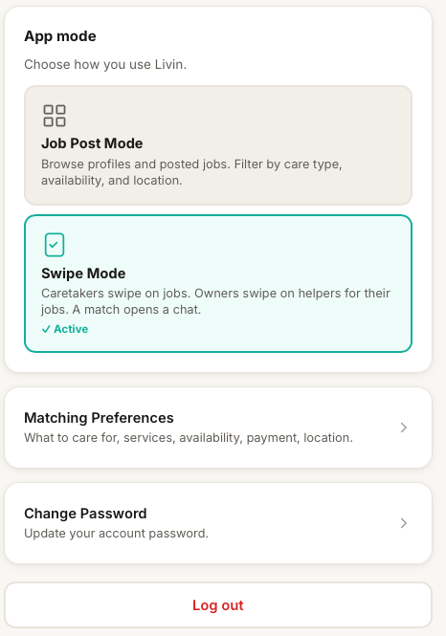
- Modify the pet owner matching preferences so the user will be visible to the caretaker:
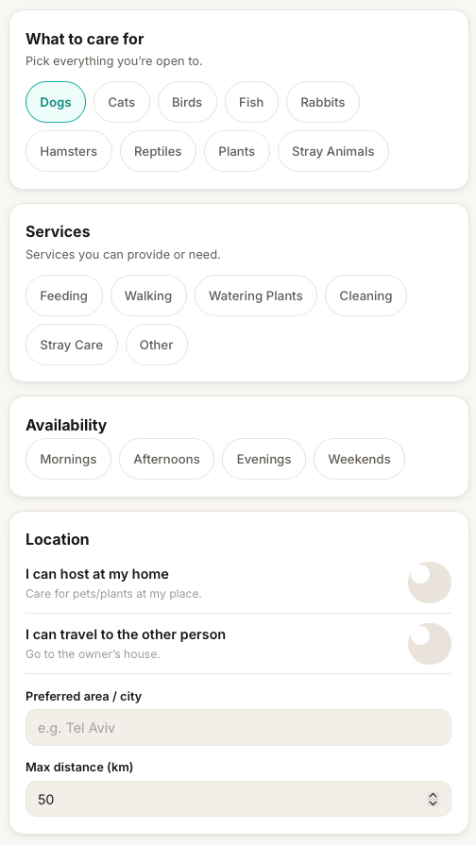
- Create a new job from the pet owner profile.
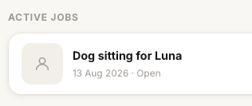
- Confirm the match from each profile to the other and begin live chat:
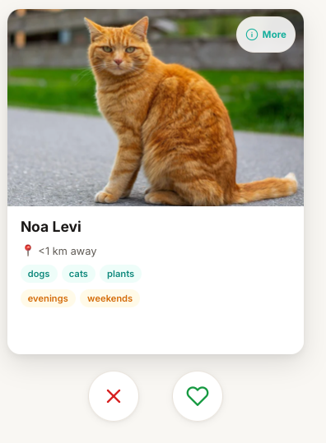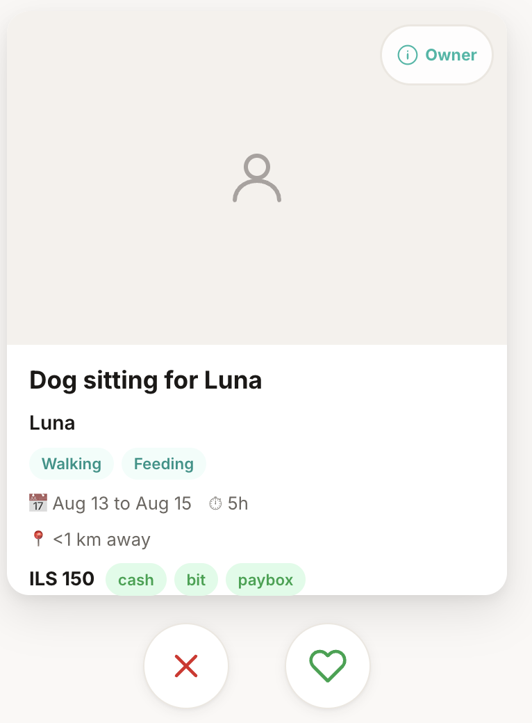
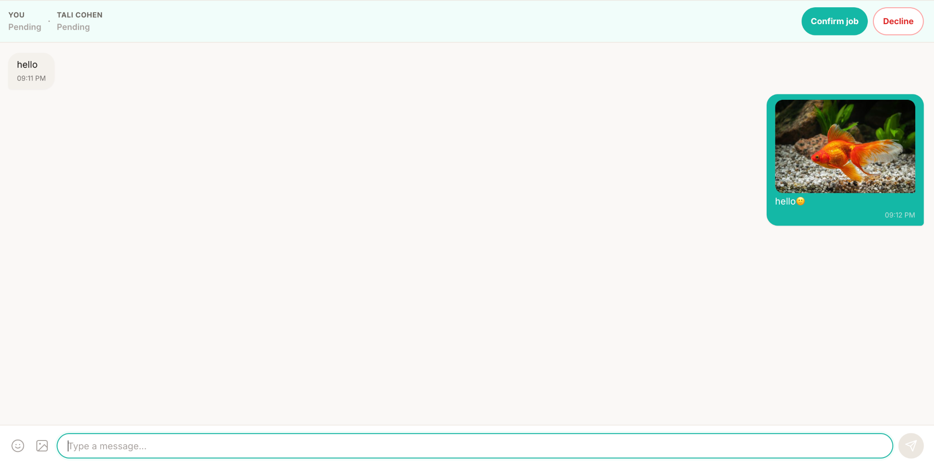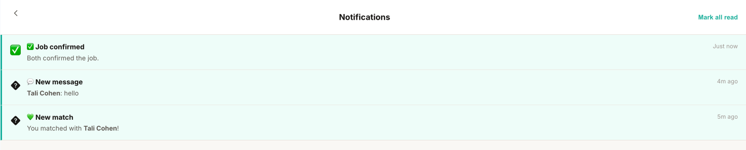
- After both users confirm the job switch back to job post mode and view the new job on the map:
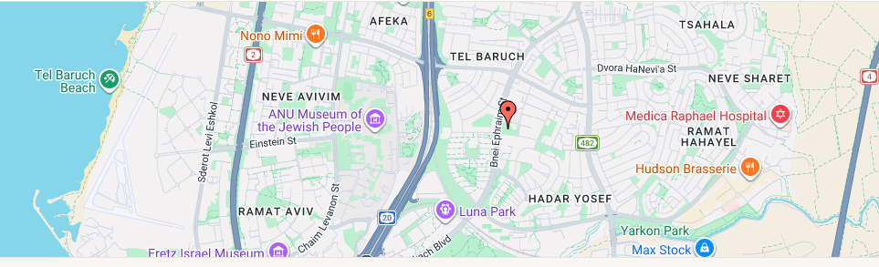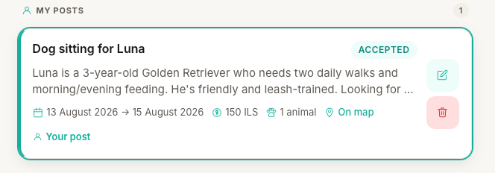

What is not implemented
- User reviews and reports
- Admin support
- Payment service integration
- Email or SMS service

